SIMATS ENGINEERING
ASSESSMENT TOOL 2

COURSE CODE: MLA03
COURSE NAME: Reinforcement learning for Environment and Agent

COURSE OUTCOME COVERED

CO2: Apply Dynamic Programming methods to solve reinforcement learning problems and derive optimal policies for decision-making tasks. ( BL2, BL3)

Assessment Tool Weightage: 30%

Dr DUMPALA PRASANTH

QUESTIONS: 10 Total Marks: 50

Annexure A
Application - Based Questions
Duration: 2Hrs

1. Design and develop a Reinforcement Learning framework a ride-sharing company uses Reinforcement Learning to match drivers with passengers efficiently. Apply RL concepts to define the state space, action space, and reward function to minimize waiting time and improve service quality. (5 Marks)

2. An e-learning platform uses Reinforcement Learning to recommend personalized study materials. Recall how exploration and exploitation strategies help balance familiar and new content recommendations. (5 Marks)

3. Design and develop a Reinforcement Learning framework a robotic vacuum cleaner uses Reinforcement Learning to clean efficiently while avoiding obstacles. Apply the concept of policy and explain how the value function improves performance over time.
(5 Marks)

4. A cryptocurrency trading system uses Reinforcement Learning to decide buy, sell, or hold actions. Outline the challenges in designing reward functions and explain how poor reward design can affect performance. (5 Marks)

5. Develop a smart grid system uses Reinforcement Learning to manage electricity distribution. Create an RL model by defining state space, action space, and reward mechanism.
(5 Marks)
6. A healthcare monitoring system uses Reinforcement Learning to adjust medication dosages. Apply RL concepts to define states, actions, and rewards, and explain how learning improves outcomes. (5 Marks)

7. Design a model drone delivery system uses Reinforcement Learning for navigation. Recall how exploration and exploitation strategies influence route optimization.
(5 Marks)

8. Design and develop a Reinforcement Learning framework a manufacturing robot uses Reinforcement Learning to optimize assembly operations. Apply the concept of policy and explain how value functions help improve efficiency.
(5 Marks)
9. An online advertising system uses Reinforcement Learning to maximize click-through rates. Outline reward design challenges and explain their impact on system performance. (5 Marks)

10. A smart irrigation system uses Reinforcement Learning to optimize water usage. Create an RL framework by defining states, actions, and reward function. (5 Marks)

Code of Conduct:

I _V. Nagendra (192425091) _ (Name / Reg No) certify that this submission is my original work and that I have adhered to the guidelines specified for this assessment.
I understand that any violation of academic integrity rules will result in disciplinary action.

V. Nagendra
Signature of the student:

RUBRICS FOR CALCULATION

Criteria | Weightage | Level 4 – Exemplary | Level 3 – Proficient | Level 2 – Developing | Level 1 – Beginning
Understanding of Problem Context | 20 | Clearly understands the problem and accurately identifies all requirements | Good understanding with minor gaps | Basic understanding; some requirements unclear | Poor understanding or misinterpretation of the problem
Application of Concepts | 30 | Accurately applies appropriate concepts to solve complex problems | Applies relevant concepts correctly with minor errors | Applies basic concepts with limited accuracy | Fails to apply appropriate concepts
Problem-Solving Approach | 20 | Logical, well-structured, and efficient approach | Mostly logical approach with minor gaps | Basic approach with some inconsistencies | Illogical or unclear approach
Accuracy of Solution | 20 | Completely correct solution with proper justification | Mostly correct with minor errors | Partially correct solution | Incorrect or incomplete solution
Clarity | 10 | Clear, well-organized, and properly explained solution | Understandable with minor clarity issues | Limited clarity and explanation | Poorly presented and difficult to understand

Q1. RL Framework for Ride-Sharing Driver–Passenger Matching
A ride-sharing company can model driver–passenger matching as an RL problem in which a central dispatch agent learns to assign available drivers to incoming ride requests in a way that minimizes passenger waiting time, minimizes driver idle/deadhead distance, and maximizes overall trip throughput across the city.
State Space
- Positions and availability status of all nearby drivers (free, en route, occupied).
- Locations, destinations, and wait time so far of pending ride requests.
- Time of day, day of week, local demand density, and traffic conditions in each zone.
Action Space
- Assign a specific driver to a specific passenger request.
- Hold/delay a match briefly to batch multiple nearby requests for a more efficient overall assignment.
- Reposition an idle driver toward a high-demand zone in anticipation of future requests.
Reward Function
- Negative reward proportional to passenger waiting time and driver idle/deadhead distance.
- Positive reward for successfully completed trips, short pickup distance, and balanced driver utilization across the fleet.
- Penalty for repeatedly ignoring or long-delaying a request (to preserve service quality/fairness).
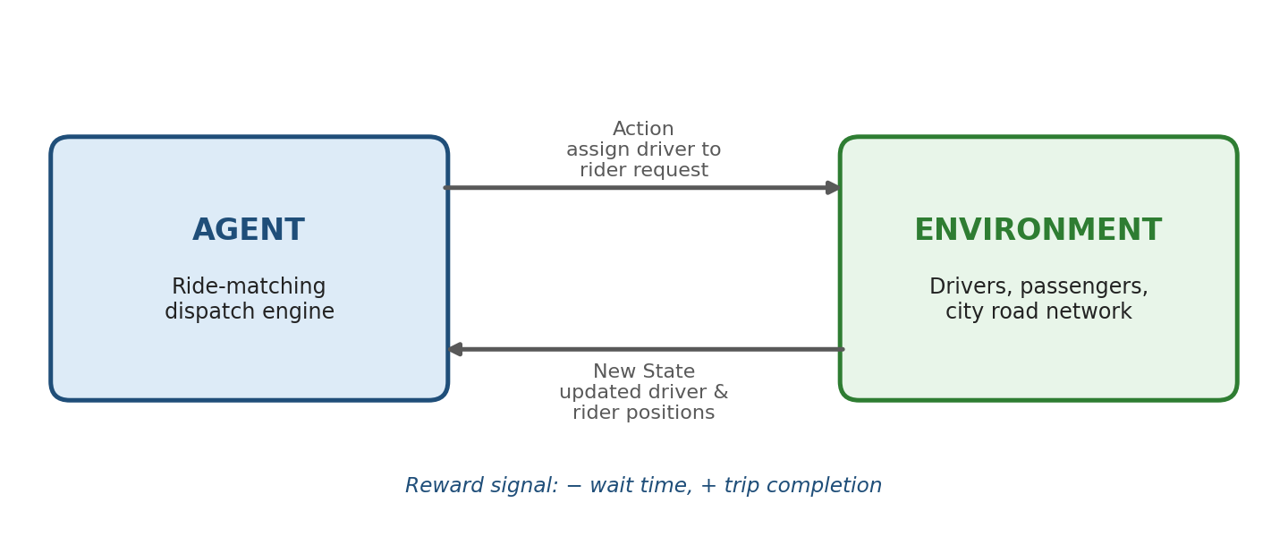
Agent–environment interaction loop for RL-based ride matching
Minimizing Waiting Time and Improving Service Quality
This is naturally framed as a combinatorial/multi-agent matching problem, often solved with deep RL (e.g., value-based dispatch using a learned value function per zone, combined with a matching algorithm such as the Hungarian algorithm at each decision epoch). The agent learns, over many trips, which assignment patterns reduce cumulative wait time city-wide rather than just the current request — for example, it may learn to hold a driver momentarily to fulfil a nearby, higher-value match instead of greedily assigning the closest driver. Continuous learning from real trip outcomes lets the policy adapt to recurring demand surges (rush hour, events) and progressively improve both wait time and driver earnings balance.

Q2. Exploration and Exploitation in E-Learning Content Recommendation
An e-learning platform can use RL to recommend the next study material (video, quiz, article, or practice set) to a learner, treating the recommender as an agent whose goal is to maximize long-term learning outcomes such as mastery, retention, and course completion, not just immediate engagement.
Recall: Exploration vs Exploitation
Exploitation means recommending content the agent already has high confidence will help the learner, based on what has worked well for similar learners or for this learner previously — e.g., continuing with a topic sequence the learner has been succeeding at. Exploration means occasionally recommending content the agent is less certain about — a new topic, a different difficulty level, or an alternative teaching format (video instead of text) — to gather more information about what actually works best for this learner.
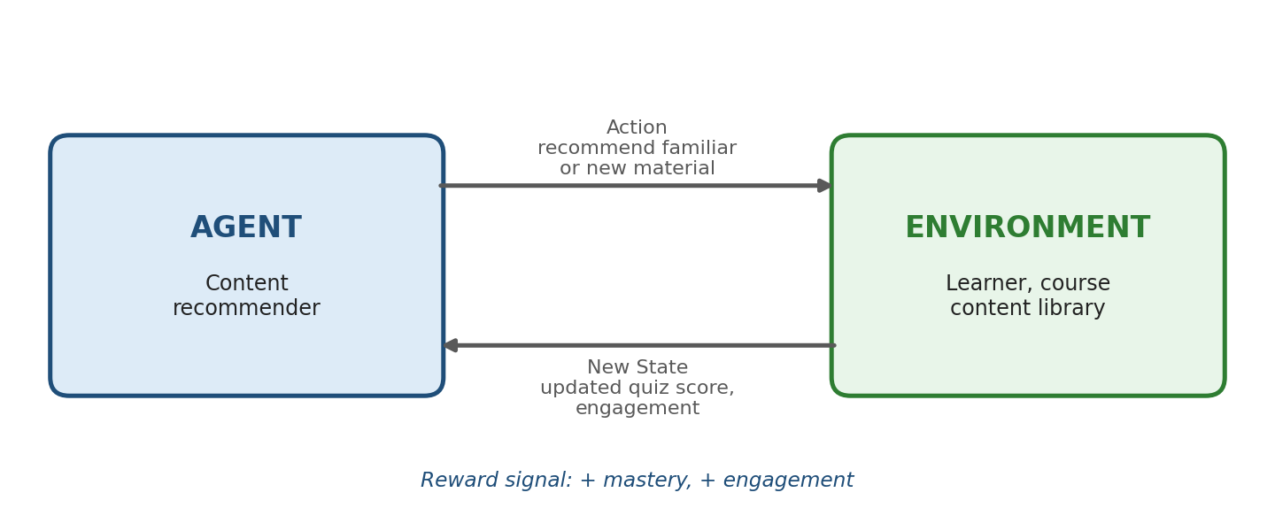
Agent–environment interaction loop for RL-based e-learning recommendation
Balancing Familiar and New Content
- Pure exploitation risks trapping the learner in a narrow, already-mastered content loop, causing boredom or a plateau in skill growth.
- Pure exploration risks recommending material that is too difficult, unfamiliar, or misaligned with the learner's current level, causing frustration and disengagement.
- Strategies such as epsilon-greedy (occasionally recommend a random/new item), UCB (favor items with high uncertainty and reasonable expected benefit), or Thompson sampling are used to blend the two systematically rather than arbitrarily.
In practice, the balance is often tuned adaptively: more exploration early (when little is known about the learner) and progressively more exploitation as the system builds confidence in what works for that individual, which improves personalization while still allowing the system to discover better content pathways as new material is added to the library.

Q3. RL Framework for a Robotic Vacuum Cleaner
A robotic vacuum cleaner can be modeled as an RL agent operating within a room, learning a cleaning policy that maximizes floor coverage and dirt pickup while avoiding collisions with furniture, walls, stairs, and other obstacles.
Design Overview
- State: the robot's current position/orientation, a map of already-cleaned area, sensor readings (bump sensors, cliff sensors, dirt sensors), and battery level.
- Action: move forward, turn left/right, reverse, activate stronger suction, or return to the charging dock.
- Reward: positive reward for cleaning new (previously uncleaned) area and efficient coverage; negative reward for collisions, revisiting already-cleaned areas unnecessarily, or running out of battery mid-task.
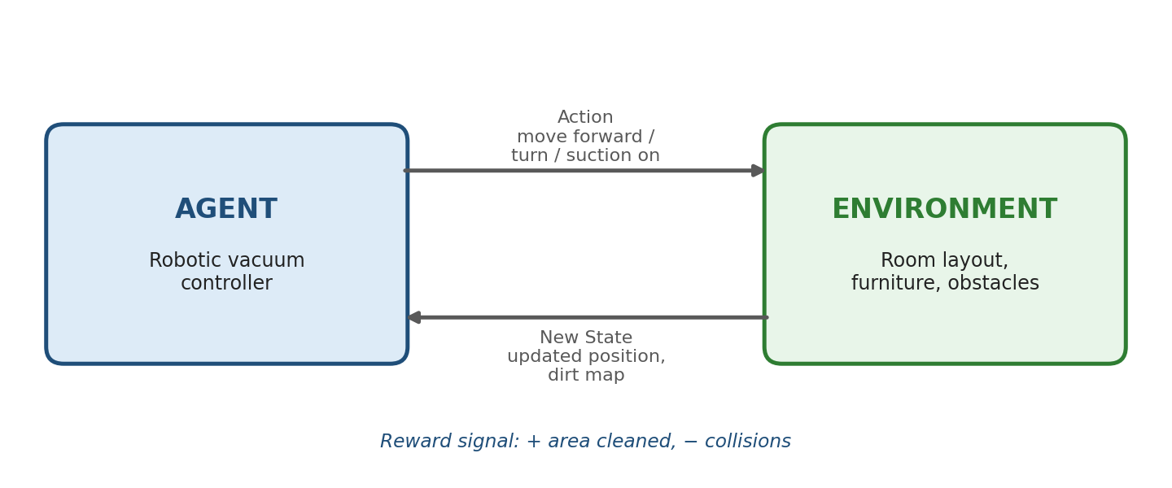
Agent–environment interaction loop for RL-based robotic vacuum cleaning
Applying the Concept of Policy
The policy (π) is the learned mapping from the robot's current sensed state to the next movement action — essentially the robot's "cleaning strategy." Early in training (or in a new, unfamiliar room), the policy may resemble close-to-random wandering; as training progresses, the policy converges toward efficient, near-systematic coverage patterns (e.g., boustrophedon/serpentine sweeping) learned purely from reward feedback rather than being explicitly programmed.
Role of the Value Function
The value function V(s) estimates the expected future cumulative reward (total additional area that can still be cleaned efficiently) from a given state, and the action-value function Q(s,a) estimates that same expectation for taking a specific action. By continually updating these estimates through experience (e.g., via Q-learning or SARSA), the robot learns to prefer actions that lead toward states with higher expected future coverage — for example, learning to prioritize navigating into an unexplored room corner over re-sweeping an already-clean open area — which is what allows performance (coverage efficiency, battery-aware planning) to improve steadily over repeated cleaning sessions.

Q4. Reward Design Challenges in Cryptocurrency Trading with RL
A cryptocurrency trading system can use RL to decide, at each time step, whether to buy, sell, or hold a given asset, with the goal of maximizing long-term portfolio value. However, designing the reward function for this domain is unusually difficult because of the extreme volatility, noise, and non-stationarity of crypto markets.
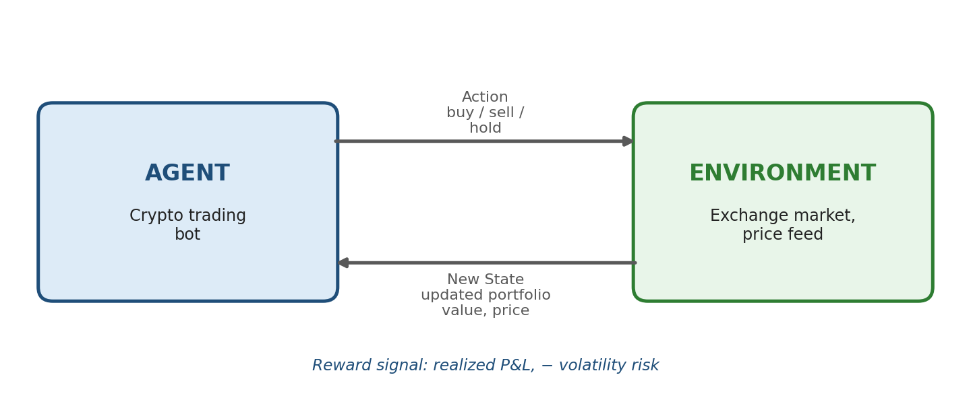
Agent–environment interaction loop for RL-based crypto trading
Key Challenges in Reward Design
- Sparse/delayed reward: the true profitability of a trade may only be evident many steps later, making simple step-wise price-change rewards a noisy and potentially misleading signal.
- Reward scale and volatility: raw profit/loss values can vary by orders of magnitude across market conditions, which can destabilize learning if not normalized (e.g., using log-returns or risk-adjusted returns).
- Ignoring risk: a reward based purely on raw return can encourage the agent to take excessively risky, high-variance positions that occasionally pay off big but are unsustainable — most practitioners instead use Sharpe-ratio-based or drawdown-penalized rewards.
- Transaction costs and slippage: if trading fees and market slippage are not built into the reward, the agent may learn a policy that trades excessively and appears profitable in simulation but loses money in live trading.
- Overfitting to historical patterns: a reward function tuned to past price data may not generalize to new market regimes (bull, bear, sideways), since financial markets are non-stationary.
Impact of Poor Reward Design
If the reward function is poorly designed — for example, rewarding raw price movement without penalizing risk or cost — the agent may learn degenerate behaviors such as excessive trading (churning) to chase short-term price bumps, taking outsized risky bets that occasionally look good in training but fail in live markets, or exploiting quirks of the training/backtesting data rather than learning genuinely robust trading behavior. This makes careful, risk-aware reward shaping and rigorous out-of-sample/live-simulation testing essential before any real capital is deployed.

Q5. RL Model for Smart Grid Electricity Distribution
A smart grid can use RL to manage the real-time distribution of electricity across generation sources, storage, and consumer demand, treating the grid controller as an agent that continuously balances supply and demand while minimizing cost and maintaining reliability.
State Space
- Current generation output from each source (thermal, solar, wind, hydro), battery/storage state of charge, and grid frequency/voltage.
- Real-time consumer demand/load across different regions or feeders, and short-term demand/weather forecasts.
- Electricity market price signals and any active demand-response commitments.
Action Space
- How much power to dispatch from each generation source or storage unit at the current interval.
- Whether to charge or discharge battery storage, and by how much.
- Whether to shed/curtail non-critical load or activate demand-response incentives during peak stress.
Reward Mechanism
- Positive reward for meeting demand reliably at minimum generation cost and low emissions.
- Negative reward for blackouts/brownouts, voltage or frequency deviations outside safe limits, and for excessive reliance on expensive peaking generation.
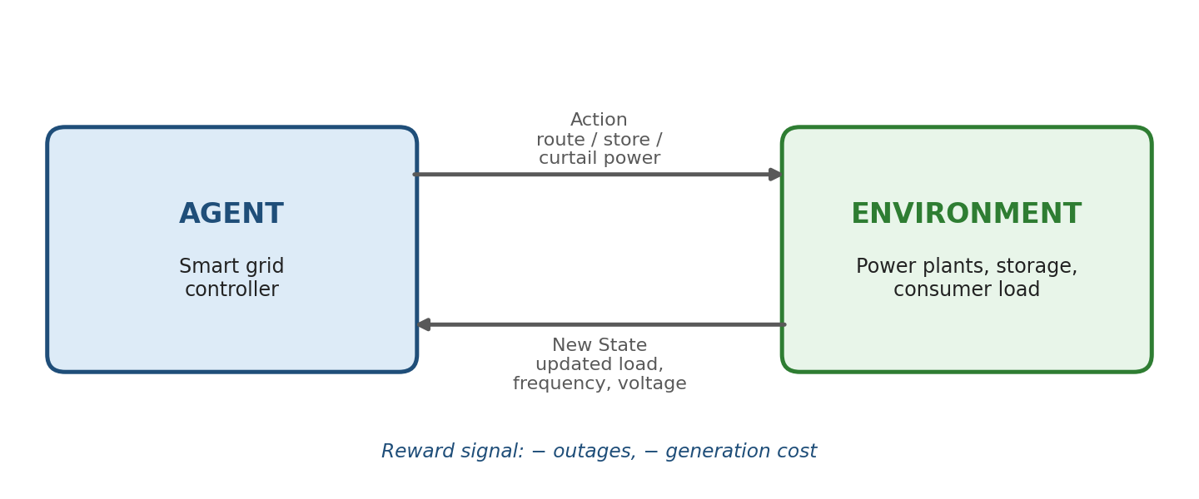
Agent–environment interaction loop for RL-based smart grid management
Why RL Fits This Problem
Because renewable generation and consumer demand both fluctuate stochastically and interact in complex, non-linear ways across a distributed network, a fixed dispatch rulebook cannot adapt well to every combination of conditions. An RL agent trained on historical and simulated grid data (often via a digital twin, since exploratory mistakes on a live grid are unacceptable) learns a dispatch policy that adapts to real-time conditions, progressively reducing cost, emissions, and reliability incidents compared with static dispatch rules.

Q6. RL for Adaptive Medication Dosage Adjustment
A healthcare monitoring system can use RL to support (typically as a decision-support tool under clinician oversight, not fully autonomous control) adaptive medication dosage adjustment, treating the dosing policy as an agent that observes a patient's evolving physiological state and recommends dosage changes to keep key health indicators within a safe, effective range.
States
- Current vital signs and lab values relevant to the condition (e.g., blood glucose for insulin dosing, INR for anticoagulants, blood pressure).
- Patient-specific factors: weight, age, kidney/liver function, and history of prior doses and responses.
- Time since last dose and any reported side effects or symptoms.
Actions
- Increase, decrease, or hold the current medication dose.
- Change dosing frequency or timing, or flag the case for clinician review when the state is highly uncertain or outside safe bounds.
Rewards
- Positive reward for keeping the relevant physiological indicator within the target therapeutic range over time.
- Large negative reward for adverse events (e.g., hypoglycemia, toxicity, dangerous vital-sign excursions) — weighted far more heavily than the benefit of being in-range, reflecting the asymmetric cost of harm.
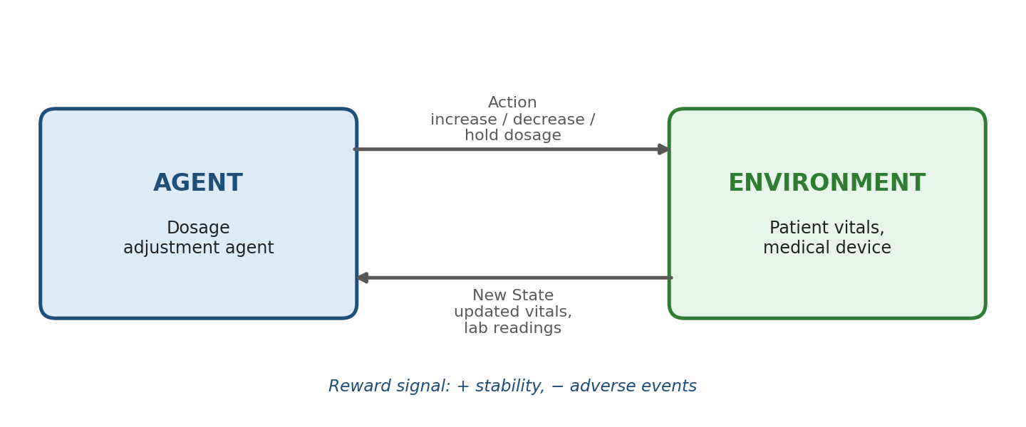
Agent–environment interaction loop for RL-based dosage adjustment
How Learning Improves Outcomes
As the system observes how each patient's physiology responds to different doses over time, it can personalize dosing far more precisely than a fixed population-average protocol, since individual metabolism, sensitivity, and comorbidities vary widely. Continuous, careful learning (usually validated extensively in simulation and constrained by strict safety bounds before any clinical deployment) allows the policy to adapt as a patient's condition changes over the course of treatment, potentially improving therapeutic stability and reducing adverse events compared with static, one-size-fits-all dosing schedules — though such systems require rigorous clinical validation, interpretability, and human oversight given the safety-critical nature of the domain.

Q7. Exploration and Exploitation in Drone Delivery Navigation
A drone delivery system can use RL to learn navigation policies that guide the drone from a depot to a delivery location while avoiding obstacles, no-fly zones, and adverse weather, and minimizing flight time and energy consumption.
Model Overview
- State: drone's GPS position, altitude, speed, heading, battery level, nearby obstacle/sensor readings, and wind/weather conditions.
- Action: adjust heading, altitude, or speed at each control interval, or choose among a small set of candidate route segments.
- Reward: negative reward for flight time, energy used, and proximity to obstacles or restricted airspace; positive reward for successful, on-time, safe delivery.
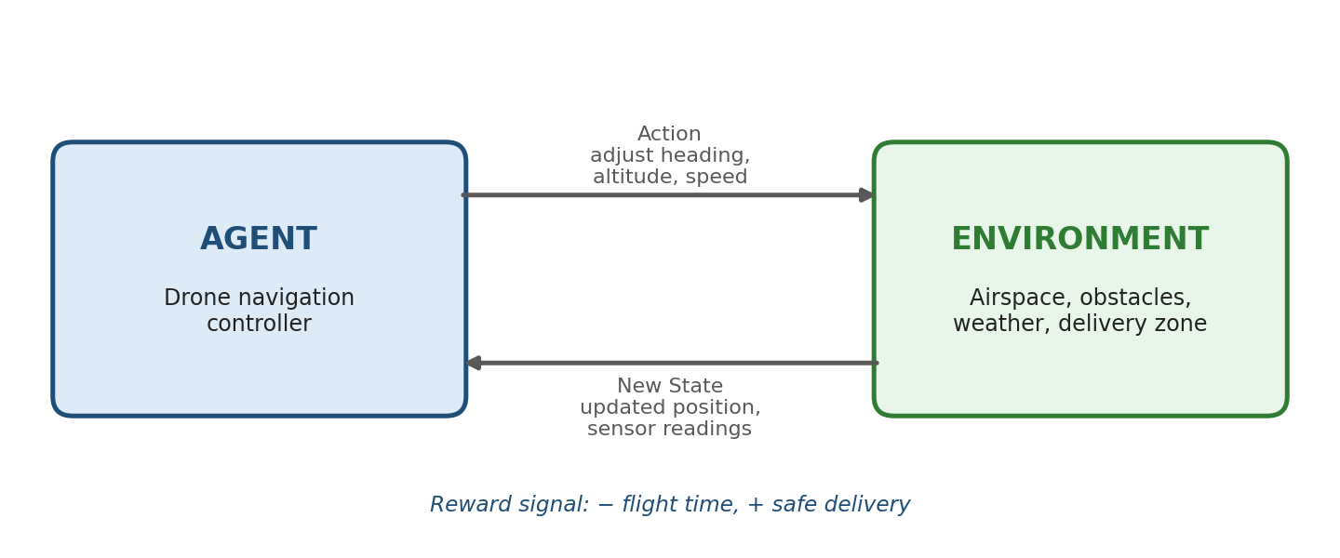
Agent–environment interaction loop for RL-based drone navigation
Recall: Influence on Route Optimization
Exploitation lets the drone reuse routes and maneuvers it has already learned to be fast and safe — important for reliability and predictability in a safety-critical application. Exploration lets the drone occasionally try alternative flight paths or altitudes it hasn't fully evaluated, which is necessary to discover better routes as new obstacles appear, delivery zones change, or wind conditions shift seasonally. Because real-world exploration mistakes can be costly or dangerous, drone RL systems typically perform most exploration in high-fidelity simulation first, then use limited, carefully bounded exploration (e.g., small perturbations around a known-safe route) during real flights, gradually refining the policy toward routes that are both efficient and provably safe.

Q8. RL Framework for Manufacturing Robot Assembly Optimization
A manufacturing robot can use RL to optimize an assembly-line operation — such as picking, placing, and joining parts — by learning a sequence of precise motions that maximizes throughput and quality while minimizing cycle time and part damage.
Design Overview
- State: current position/orientation of the robot arm, position and orientation of the part being assembled, stage of the assembly sequence, and sensor feedback (force/torque, vision).
- Action: joint movements, gripper open/close, force applied during insertion or fastening, and transition to the next assembly sub-task.
- Reward: positive reward for successful, precise completion of each assembly step within time and quality tolerances; negative reward for part misalignment, excessive force (risking damage), collisions, or exceeding the target cycle time.
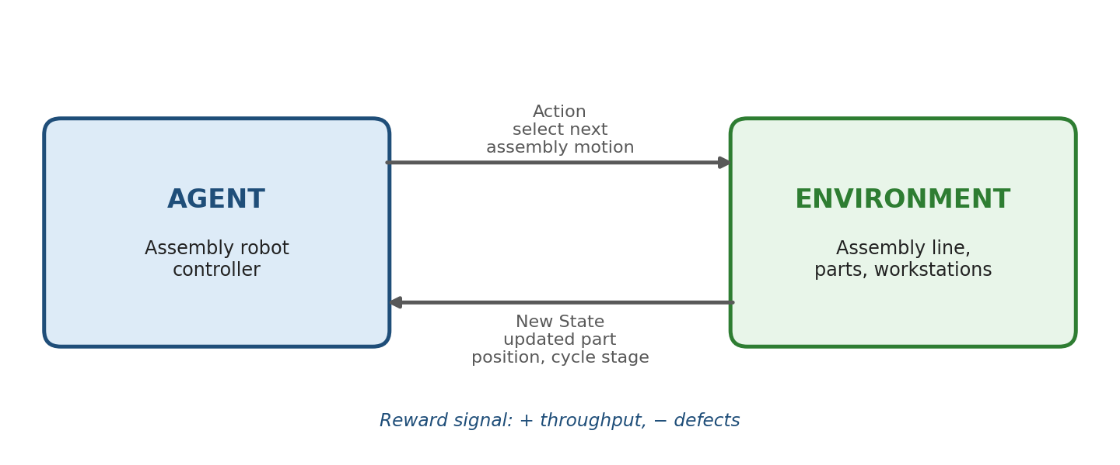
Agent–environment interaction loop for RL-based assembly optimization
Applying Policy and Value Function
The policy (π) is the learned mapping from the robot's sensed state (arm position, part alignment, assembly stage) to the next motor command — effectively the robot's assembly "skill." Initially this policy may be imprecise or inefficient (e.g., overshooting during insertion), but through repeated trials (often in simulation first, then fine-tuned on the real line) it converges toward smooth, efficient, high-precision motions.
The value function estimates the expected future reward (successful completions, remaining time budget) from a given state, guiding the robot to prefer intermediate configurations that are more likely to lead to a successful, fast completion of the current assembly cycle. As the value estimates become more accurate with experience, the robot's action choices improve correspondingly, leading to steadily rising throughput, lower defect/rework rates, and reduced cycle time compared to a fixed, manually programmed motion sequence that cannot adapt to part variability or wear.

Q9. Reward Design Challenges in RL-Based Online Advertising
An online advertising system can use RL to select which ad to serve to a given user in a given context, with the goal of maximizing click-through rate (CTR) and, more broadly, downstream conversions and long-term platform revenue, treating the ad-serving engine as an agent choosing among a large, constantly changing pool of candidate ads.
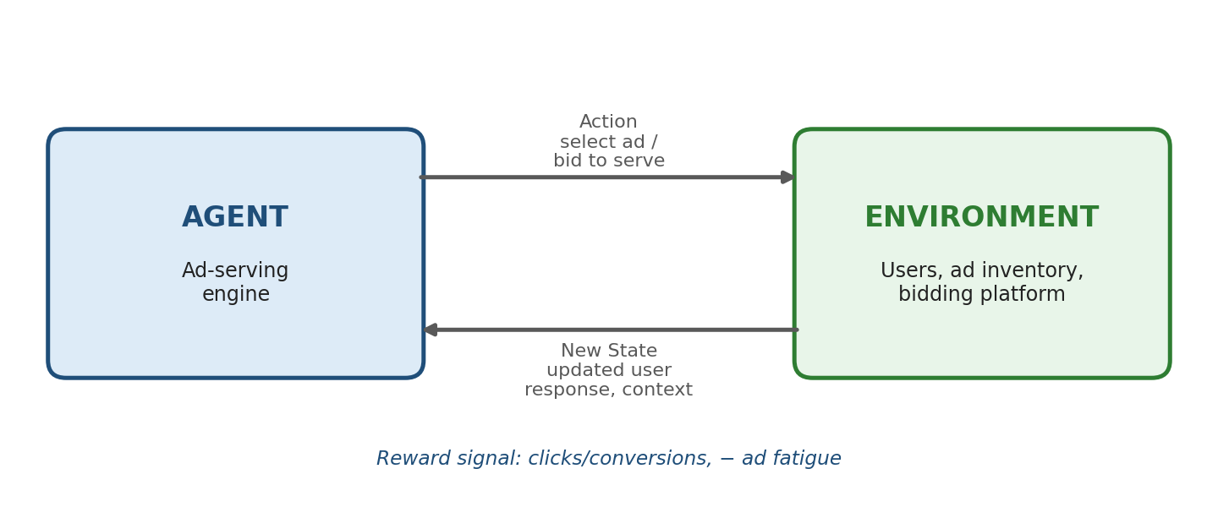
Agent–environment interaction loop for RL-based ad serving
Reward Design Challenges
- Sparse and highly imbalanced feedback: clicks (and especially conversions) are rare events relative to total impressions, making the reward signal sparse and noisy.
- Short-term vs long-term objectives: optimizing purely for immediate CTR can favor sensational or misleading ads that generate clicks but harm user trust, satisfaction, and long-term platform engagement — a classic case of reward misspecification.
- Ad fatigue and diminishing returns: repeatedly showing the same high-CTR ad to a user reduces its future effectiveness and can increase annoyance, so the reward should account for variety and user experience, not just immediate response.
- Delayed conversions: a click may not translate into a completed purchase/conversion until much later (or on a different device), complicating credit assignment between the RL agent's action and the eventual outcome.
- Auction and budget interactions: reward must also account for the cost of serving the ad (bid price paid) relative to the value gained, not click-through rate in isolation.
Impact on System Performance
If the reward function is defined narrowly as immediate CTR, the system tends to over-optimize for attention-grabbing but low-quality ads, degrading user trust and long-run engagement even as short-term metrics look strong — a well-documented failure mode sometimes called "reward hacking" or "metric gaming." Well-designed systems instead use composite or longer-horizon rewards (e.g., combining CTR, conversion rate, user satisfaction signals, and revenue net of cost) and often constrain exploration and frequency capping to protect user experience alongside advertiser and platform performance.

Q10. RL Framework for Smart Irrigation Water Optimization
A smart irrigation system can use RL to decide when and how much to irrigate different zones of a field, treating the irrigation controller as an agent that learns to maximize crop yield and health while minimizing water usage and cost.
States
- Current soil moisture levels per zone, crop growth stage, and recent/forecast weather (rainfall, temperature, humidity, evapotranspiration rate).
- Water reservoir/supply availability and any irrigation cost or restriction constraints (e.g., time-of-use water pricing, drought regulations).
Actions
- Irrigate a specific zone (and for how long/how much volume), or withhold irrigation for that zone during the current interval.
- Adjust irrigation scheduling across zones to prioritize water-stressed areas first.
Reward Function
- Positive reward for maintaining soil moisture within the crop's optimal range and for healthy crop growth/yield indicators.
- Negative reward for water overuse (waste, cost, and environmental impact), for under-watering that causes crop stress, and for irrigating just before forecast rainfall (wasted water).
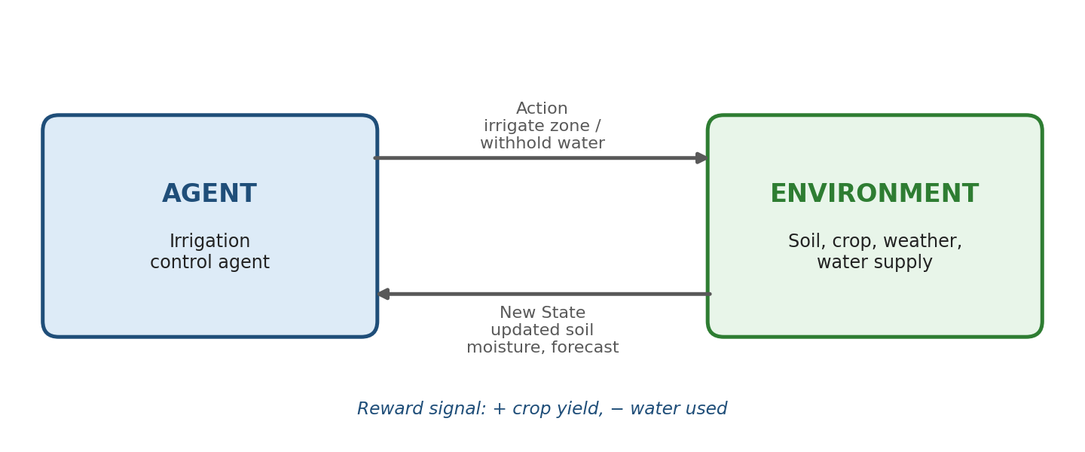
Agent–environment interaction loop for RL-based irrigation control
Expected Impact
Because soil moisture dynamics depend on many interacting, partly unpredictable factors (weather, soil type, crop stage), a fixed watering schedule is typically far less efficient than an adaptive policy. By continuously incorporating live sensor readings and weather forecasts into the state, the RL agent learns zone-specific irrigation patterns tailored to real conditions rather than a generic calendar, which in practice can substantially reduce total water consumption while maintaining or improving crop yield compared with fixed-schedule irrigation.

